PYTHON ACTIVITY BASED LEARNING

SHAIK.HANIFA
-CSM3
ROLL.NO:26001021

PROGRAM-1
University Scholarship Allocation: Design a system that evaluates applicants using aggregate marks, subject-wise minimum scores, attendance, and income criteria, ranks eligible students, and resolves ties using predefined rules.
1.Problem Solving Approach
Identify the inputs, processing requirements, and outputs.
- Input: Student name, aggregate marks, subject-wise marks, attendance percentage, and annual family income.
- Processing: Check eligibility, identify rejected applicants, rank eligible students, and resolve ties.
- Output: List of eligible students in rank order and list of rejected applicants.

2. Eligibility criteria
For this example, assume the university uses the following rules.
Criterion | Requirement
Aggregate marks | At least 75%
Mathematics | At least 60 marks
Physics | At least 50 marks
Chemistry | At least 50 marks
Attendance | At least 80%
Annual family income | At most ₹3,00,000
Tie-breaking rules:
  - Higher aggregate marks rank first.
  - If aggregate marks are equal, higher attendance ranks first.
  - If attendance is also equal, lower annual family income ranks first.
  - If all three are equal, alphabetical order of the student's name decides the rank.
These are illustrative rules; an actual university should use its officially approved criteria.
3.Algorithm
- Start.
- Read the number of applicants.
- Store each applicant's name, aggregate marks, subject marks, attendance, and annual family income.
- Check all eligibility conditions.
- If every condition is satisfied, add the applicant to the eligible list.
- Sort eligible applicants by aggregate marks in descending order.
- Resolve ties using attendance in descending order, income in ascending order, and name in alphabetical order.
- Display the ranked eligible applicants.
- Stop.
4.Psudocode
BEGIN

eligible_students = empty list

INPUT number_of_applicants

FOR each applicant:
INPUT name
INPUT aggregate_marks
INPUT mathematics_marks
INPUT physics_marks
INPUT chemistry_marks
INPUT attendance
INPUT annual_income

IF aggregate_marks >= 75 AND
mathematics_marks >= 60 AND
physics_marks >= 50 AND
chemistry_marks >= 50 AND
attendance >= 80 AND
annual_income <= 300000 THEN

ADD applicant to eligible_students

END IF
END FOR

SORT eligible_students BY:
aggregate_marks descending
attendance descending
annual_income ascending
name ascending

DISPLAY eligible_students with ranks

END
5.Flowchart
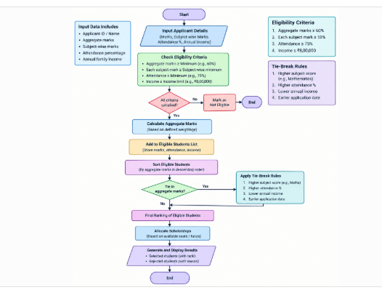

1. Python implementation
The following program demonstrates all the main concepts in the question.
python

# University Scholarship Allocation System

MIN_AGGREGATE = 75
MIN_MATHS = 60
MIN_PHYSICS = 50
MIN_CHEMISTRY = 50
MIN_ATTENDANCE = 80
MAX_INCOME = 300000

# Nested list: each applicant is represented by a list
applicants = [
["Ananya", 90, 85, 80, 82, 95, 200000],
["Bharat", 90, 85, 80, 82, 90, 180000],
["Charan", 78, 65, 55, 60, 85, 250000],
["Divya", 88, 70, 65, 68, 92, 350000],
["Esha", 82, 55, 70, 65, 90, 150000],
["Farhan", 85, 75, 70, 72, 88, 220000],
]

eligible = []
rejected = []

# Check eligibility using a loop and conditional statements
for student in applicants:
name, aggregate, maths, physics, chemistry, attendance, income = student

if (aggregate >= MIN_AGGREGATE
and maths >= MIN_MATHS
and physics >= MIN_PHYSICS
and chemistry >= MIN_CHEMISTRY
and attendance >= MIN_ATTENDANCE
and income <= MAX_INCOME):

eligible.append(student)
else:
rejected.append(name)

# Tuple operations and sorting
# Sort by aggregate descending, attendance descending,
# income ascending, and name alphabetically.
eligible.sort(key=lambda s: (-s[1], -s[5], s[6], s[0]))

# Display results using string formatting
print("SCHOLARSHIP RANK LIST")
print("-" * 75)

for rank, student in enumerate(eligible, start=1):
name, aggregate, maths, physics, chemistry, attendance, income = student

print(
f"Rank {rank}: {name} | "
f"Aggregate: {aggregate}% | "
f"Attendance: {attendance}% | "
f"Income: Rs. {income}"
)

print("\nRejected applicants:", ", ".join(rejected))
8. Expected output
text
SCHOLARSHIP RANK LIST
---------------------------------------------------------------------------
Rank 1: Ananya | Aggregate: 90% | Attendance: 95% | Income: Rs. 200000
Rank 2: Bharat | Aggregate: 90% | Attendance: 90% | Income: Rs. 180000
Rank 3: Farhan | Aggregate: 85% | Attendance: 88% | Income: Rs. 220000
Rank 4: Charan | Aggregate: 78% | Attendance: 85% | Income: Rs. 250000

Rejected applicants: Divya, Esha

